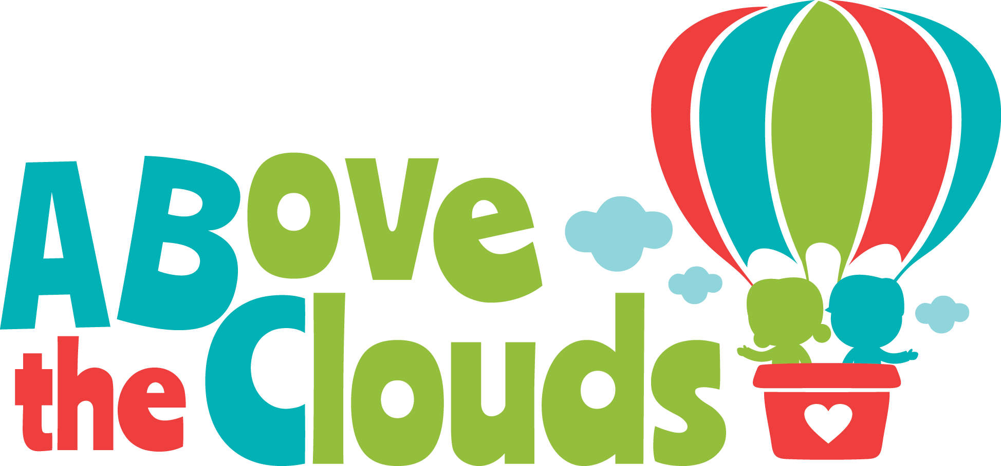
Job Opportunity
We are looking for people who enjoy very young children and understand what they need to develop optimally and happily, even when disabilities or hardships are affecting them. We need team players who want to work with and listen to a variety of specialists and, most importantly, each child’s family. Our team helps provide opportunities for children and families to rise “above the clouds” of fear, confusion, or worry that some delays or difficulties bring.
Our general teachers (home not classroom based) are both:
&

Infant Development Specialists
- Master’s Degree in child development/early childhood education with min. 15 units of formal instruction in at least one of the following areas:
▪ Typical and atypical development
▪ Infant assessment
▪ Family involvement in infancy
- And/or a valid license or certification:
▪ Occupational Therapy
▪ Physical Therapy
▪ Special Education
▪ Speech and Language Pathology
▪ Psychology
▪ OR Nursing
- Ability to train and supervise Early Interventionists and expertise to provide evaluations of infants and toddlers using accepted tests and measurements, as well as professional opinion.
- Knowledgeable and comfortable about high-risk infant health and development
Early Interventionists
- Bachelor’s Degree in one of the following:
⬥ Psychology
⬥ Behavioral Sciences
⬥ Pediatric Health Care Field
⬥ Child Development
⬥ Early Childhood Education
⬥ Related Social Services
- Working knowledge of Early Childhood Education Programs (birth to 5 years of age) and Regional Center Early Start (early intervention) Programs.

- Demonstrated knowledge of home visiting, parent education, and developmental assessments and reports.

- Minimum of 2 years of experience working in an Early Childhood developmental program

If you can see yourself filling one of these roles AND you would like to be able to make your own hours and be paid $50-90 per visit depending on your experience, with room to grow your pay and your clientele at your own pace, purchase health insurance with company subsidies, and work with a highly qualified and motivated group of professionals, call (209) 505-4355 and ask for Bonnie, or email bonnie@abovetheclouds.services.

